It is a relation between classes , where one instance of entity should be mapped with exactly one instance of another entity.

Example: Every employee should have exactly one inidividual account.

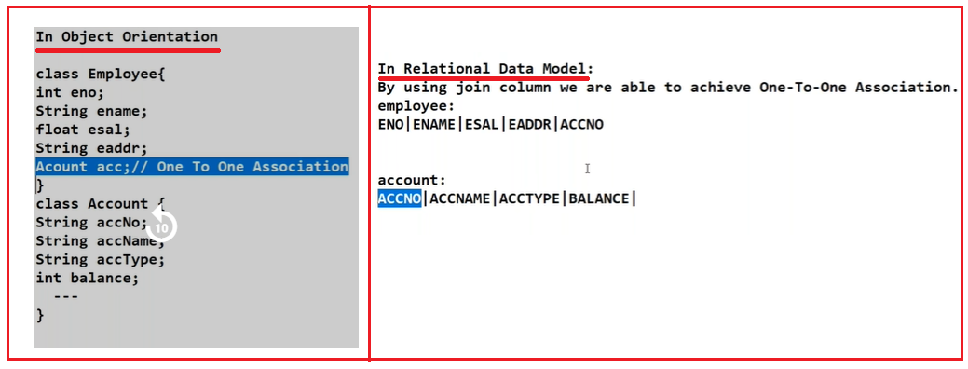

**1.One-to-one association mismatching solution using xml tags:**

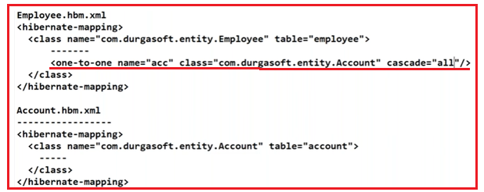

**2. One-to-One Association mismatching solution using Annotations:**



**This annotation should be applied to container class only.**

**Example:- Using XML tag.**

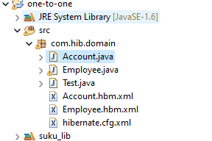

**Domain classes:**

**1.Employee.java**

**package** com.hib.domain;

**import** java.io.Serializable;

**public** **class** Employee **implements** Serializable {

**private** **int** eno;

**private** **int** accNo;

**public** **int** getAccNo() {

**return** accNo;

}

**public** **void** setAccNo(**int** accNo) {

**this**.accNo = accNo;

}

**private** String ename;

**private** **float** esal;

**private** Account acc;

**private** String eaddr;

**public** **int** getEno() {

**return** eno;

}

**public** **void** setEno(**int** eno) {

**this**.eno = eno;

}

**public** String getEname() {

**return** ename;

}

**public** **void** setEname(String ename) {

**this**.ename = ename;

}

**public** **float** getEsal() {

**return** esal;

}

**public** **void** setEsal(**float** esal) {

**this**.esal = esal;

}

**public** String getEaddr() {

**return** eaddr;

}

**public** **void** setEaddr(String eaddr) {

**this**.eaddr = eaddr;

}

**public** Account getAcc() {

**return** acc;

}

**public** **void** setAcc(Account acc) {

**this**.acc = acc;

}

}

**2.Account.java**

**package** com.hib.domain;

**public** **class** Account {

**private** **long** accNo;

**private** String accName;

**private** String accType;

**private** **float** balance;

**public** **long** getAccNo() {

**return** accNo;

}

**public** **void** setAccNo(**long** accNo) {

**this**.accNo = accNo;

}

**public** String getAccName() {

**return** accName;

}

**public** **void** setAccName(String accName) {

**this**.accName = accName;

}

**public** String getAccType() {

**return** accType;

}

**public** **void** setAccType(String accType) {

**this**.accType = accType;

}

**public** **float** getBalance() {

**return** balance;

}

**public** **void** setBalance(**float** balance) {

**this**.balance = balance;

}

}

**Hibernate Mapping File: Employee.hbm.xml**

<?xml version=*"1.0"* encoding=*"UTF-8"*?>

<!DOCTYPE hibernate-mapping PUBLIC

"-//Hibernate/Hibernate Mapping DTD 3.0//EN"

"http://www.hibernate.org/dtd/hibernate-mapping-3.0.dtd">

<hibernate-mapping>

<class name=*"com.hib.domain.Employee"* table=*"Employee"*>

<id name=*"eno"* column=*"eno"*/>

<property name=*"ename"* column=*"ename"*/>

<property name=*"accNo"* column=*"accNo"*/>

<property name=*"esal"* column=*"esal"*/>

<property name=*"eaddr"* column=*"eaddr"*/>

<one-to-one name=*"acc"* class=*"com.hib.domain.Account"* cascade=*"all"*/>

</class>

</hibernate-mapping>

**Hibernate Mapping File: Account.hbm.xml**

<?xml version=*"1.0"* encoding=*"UTF-8"*?>

<!DOCTYPE hibernate-mapping PUBLIC

"-//Hibernate/Hibernate Mapping DTD 3.0//EN"

"http://www.hibernate.org/dtd/hibernate-mapping-3.0.dtd">

<hibernate-mapping>

<class name=*"com.hib.domain.Account"* table=*"account"*>

<id name=*"accNo"*/>

<property name=*"accName"*/>

<property name=*"accType"*/>

<property name=*"balance"*/>

</class>

</hibernate-mapping>

**Hibernate configuration File: hibernate.cfg.xml**

<?xml version=*"1.0"* encoding=*"UTF-8"*?>

<!DOCTYPE hibernate-configuration PUBLIC

"-//Hibernate/Hibernate Configuration DTD 3.0//EN"

"http://www.hibernate.org/dtd/hibernate-configuration-3.0.dtd">

<hibernate-configuration>

<session-factory>

<property name=*"hibernate.connection.driver_class"*>oracle.jdbc.OracleDriver</property>

<property name=*"hibernate.connection.url"*>jdbc:oracle:thin:@localhost:1521:xe</property>

<property name=*"hibernate.connection.username"*>system</property>

<property name=*"hibernate.connection.password"*>tiger</property>

<property name=*"hibernate.dialect"*>org.hibernate.dialect.OracleDialect</property>

<mapping resource=*"com/hib/domain/Employee.hbm.xml"*/>

<mapping resource=*"com/hib/domain/Account.hbm.xml"*/>

</session-factory>

</hibernate-configuration>

**ClientApplication: Test.java**

package com.hib.domain;

import org.hibernate.Session;

import org.hibernate.SessionFactory;

import org.hibernate.Transaction;

import org.hibernate.cfg.Configuration;

public class Test {

public static void main(String[] args) {

Configuration cfg=new Configuration();

cfg.configure("com/hib/domain/hibernate.cfg.xml");

SessionFactory sf=cfg.buildSessionFactory();

Session s=sf.openSession();

Transaction t=s.beginTransaction();

Employee e=new Employee();

Account a=new Account();

e.setEno(1);

e.setEname("suku");

e.setEsal(7000f);

e.setEaddr("nlr");

e.setAccNo(7);

a.setAccNo(7);

a.setAccName("suku");

a.setAccType("saving");

a.setBalance(7000);

e.setAcc(a);

s.save(e);

t.commit();

}

}

**Output:**

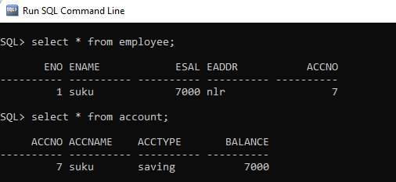

**Example:2 Using Annotations**

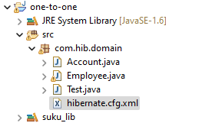

**Domain classes:**

**1.Employee.java**

package com.hib.domain;

import java.io.Serializable;

import javax.persistence.CascadeType;

import javax.persistence.Column;

import javax.persistence.Entity;

import javax.persistence.Id;

import javax.persistence.OneToOne;

import javax.persistence.Table;

@Entity

@Table(name="employee")

public class Employee implements Serializable {

@Id

@Column(name="eno")

private int eno;

@Column(name="ename")

private String ename;

@Column(name="esal")

private float esal;

@Column(name="eaddr")

private String eaddr;

@OneToOne(cascade=CascadeType.ALL)

private Account acc1;

public int getEno() {

return eno;

}

public void setEno(int eno) {

this.eno = eno;

}

public String getEname() {

return ename;

}

public void setEname(String ename) {

this.ename = ename;

}

public float getEsal() {

return esal;

}

public void setEsal(float esal) {

this.esal = esal;

}

public String getEaddr() {

return eaddr;

}

public void setEaddr(String eaddr) {

this.eaddr = eaddr;

}

public Account getAcc1() {

return acc1;

}

public void setAcc1(Account acc) {

this.acc1 = acc;

}

}

**2.Account.java**

package com.hib.domain;

import javax.persistence.Column;

import javax.persistence.Entity;

import javax.persistence.Id;

import javax.persistence.Table;

@Entity

@Table(name="account")

public class Account {

@Id

@Column(name="accNo")

private String accNo;

@Column(name="accName")

private String accName;

@Column(name="accType")

private String accType;

@Column(name="balance")

private float balance;

public String getAccNo() {

return accNo;

}

public void setAccNo(String accNo) {

this.accNo = accNo;

}

public String getAccName() {

return accName;

}

public void setAccName(String accName) {

this.accName = accName;

}

public String getAccType() {

return accType;

}

public void setAccType(String accType) {

this.accType = accType;

}

public float getBalance() {

return balance;

}

public void setBalance(float balance) {

this.balance = balance;

}

}

**Hibernate Configuration File: hibernat.cfg.xml**

<?xml version=*"1.0"* encoding=*"UTF-8"*?>

<!DOCTYPE hibernate-configuration PUBLIC

"-//Hibernate/Hibernate Configuration DTD 3.0//EN"

"http://www.hibernate.org/dtd/hibernate-configuration-3.0.dtd">

<hibernate-configuration>

<session-factory>

<property name=*"hibernate.connection.driver_class"*>oracle.jdbc.OracleDriver</property>

<property name=*"hibernate.connection.url"*>jdbc:oracle:thin:@localhost:1521:xe</property>

<property name=*"hibernate.connection.username"*>system</property>

<property name=*"hibernate.connection.password"*>tiger</property>

<property name=*"hibernate.dialect"*>org.hibernate.dialect.OracleDialect</property>

<mapping class=*"com.hib.domain.Employee"*/>

<mapping class=*"com.hib.domain.Account"*/>

</session-factory>

</hibernate-configuration>

**ClientApplication:Test.java**

package com.hib.domain;

import org.hibernate.Session;

import org.hibernate.SessionFactory;

import org.hibernate.Transaction;

import org.hibernate.cfg.Configuration;

public class Test {

public static void main(String[] args) {

Configuration cfg=new Configuration();

cfg.configure("com/hib/domain/hibernate.cfg.xml");

SessionFactory sf=cfg.buildSessionFactory();

Session s=sf.openSession();

Transaction t=s.beginTransaction();

Employee e=new Employee();

Account a=new Account();

e.setEno(1);

e.setEname("suku");

e.setEsal(7000f);

e.setEaddr("nlr");

a.setAccNo("7");

a.setAccName("suku");

a.setAccType("saving");

a.setBalance(7000);

e.setAcc1(a);

s.save(e);

t.commit();

}

}

**Output:**

